Services and Networking

What is Networking?
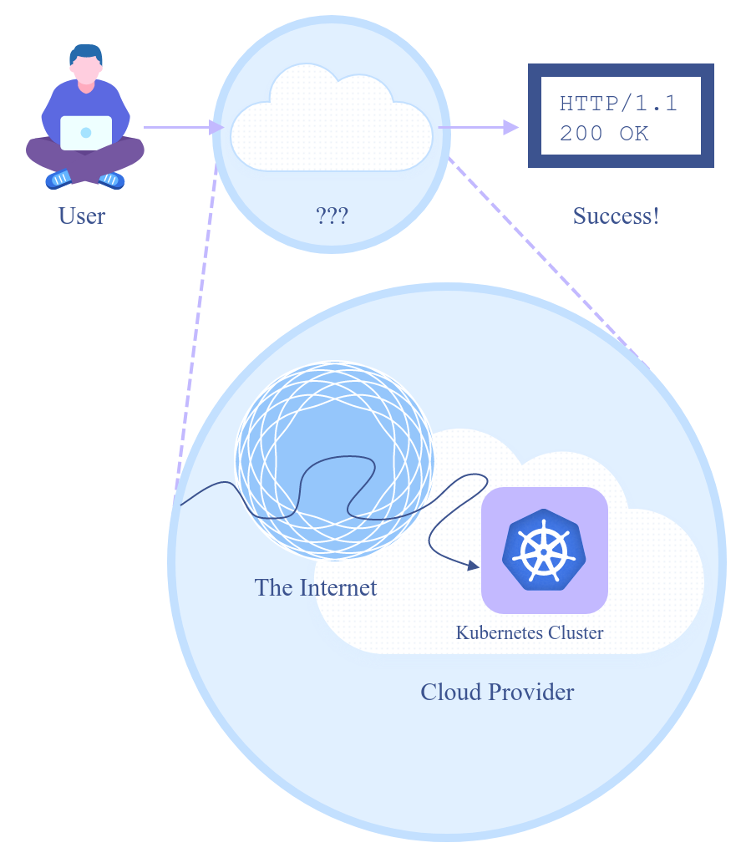
Simply put, Networking is when one computer can talk to another. This communication happens in many diverse ways but you can think of it like a FedEx delivery.

Essentially all devices connected to the internet have an IP address, which is like your house address.

They also have their own MAC address, which is the like name of the home owner.

Sending a package to another person is considered creating “traffic” over the internet. Packages or packets in networking, traverse the internet to send data to your chosen destination. The packet will have your IP address and MAC address, the same way a FedEx package would have your name and home address.

Networking includes all of the protocols or rules used on the internet to communicate from point a to point b. Some of those protocols regulate services like DNS, HTTP, or HTTPS traffic.

The OSI Model
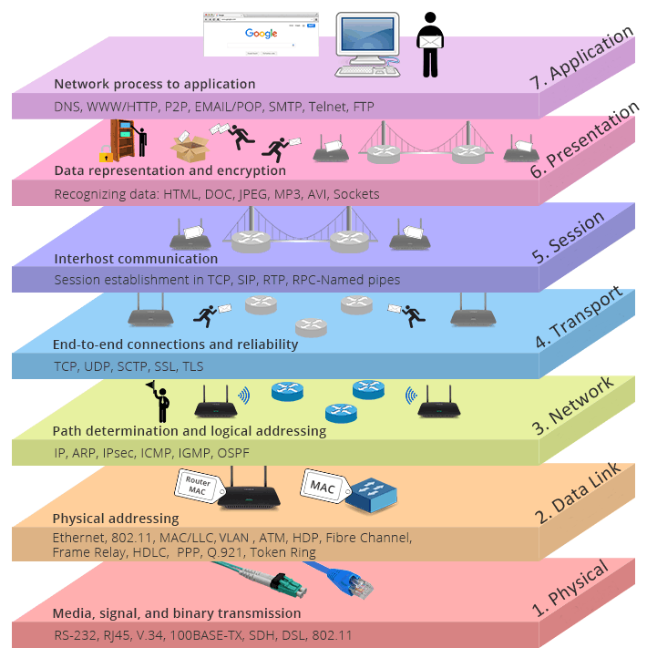

Understanding Connectivity Between Pods

A pod consists of one or more containers that are collocated on the same host, and are configured to share a network stack and other resources such as volumes. All pods on a container can reach one another on a localhost. If I have a container running nginx and listening on port 80 and another container running prometheus, the second container can connect to the first via http://localhost.
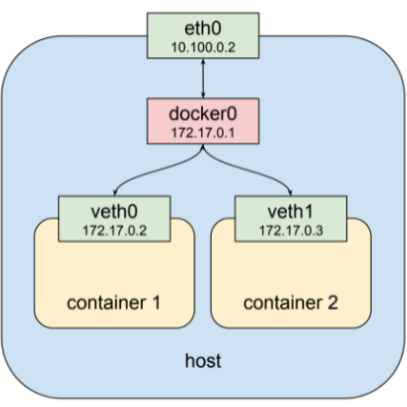
Here we have two separate pods running container 1 and container 2. The eth0 port is the physical interface that then uses docker0 as a bridge for the containers.

Notice that both virtual ethernet interfaces have separate IP’s but can communicate by default because they're in the same subnet.

Kubernetes implements this pattern by creating a special container for each pod whose only purpose is to provide a network interface for the other containers. If you ssh in to a node that has pods scheduled on it and run docker ps you will see at least one container that was started with the pause command. The pause command suspends the current process until a signal is received so these containers do nothing at all except sleep until Kubernetes sends them a SIGTERM.

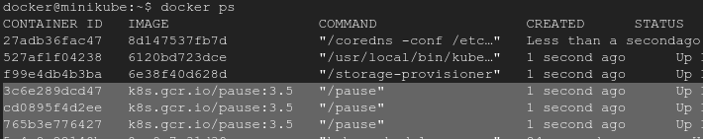
Despite this lack of activity the “pause” container is the heart of the pod, providing the virtual network interface that all the other containers will use to communicate with each other and the outside world.

The private networks 10.100.0.2 and 10.100.0.3 are for the two instances in this example and our router is 10.100.0.1 Given this setup each instance can communicate with the other on eth0. The pods clusters are hanging off a bridge on a different network entirely, one that is virtual and exists only on a specific node.
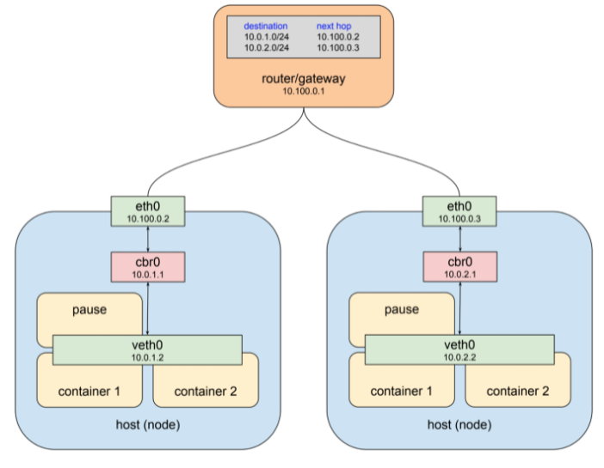
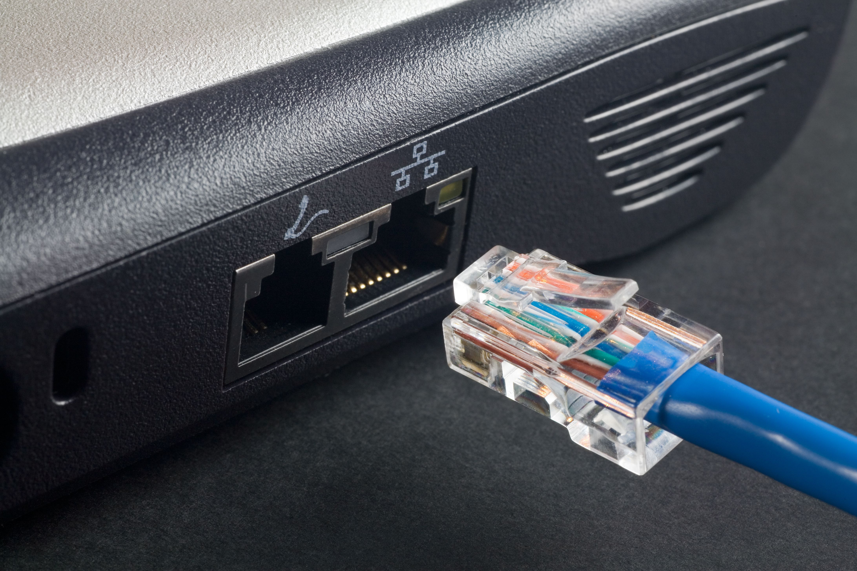
The easiest way to think about ethernet is the one on your laptop. These eth0 ports exist physically and also in virtualized software to provide a connection from the device you’re using to another server, cloud router, or physical router responsible for directing internet traffic.
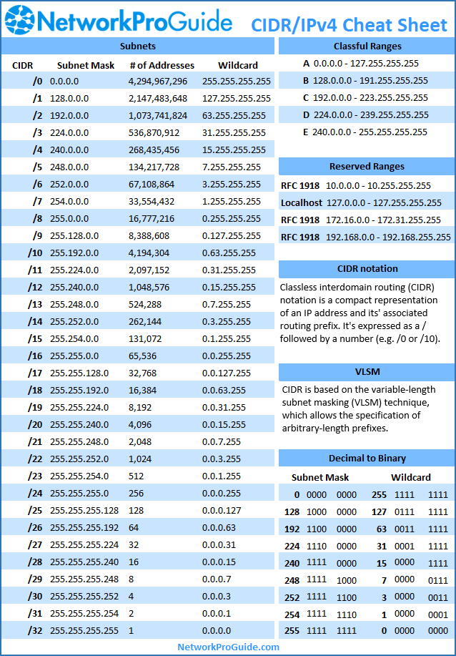
A Brief Introduction to Subnetting
Hands On – Connect a Pod to a Service

I. Setup your deployment and Verify

The first step requires us deploy the following manifest. This will setup a pod and service that allows network communication on port 80.

Service Pod
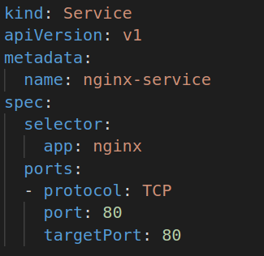
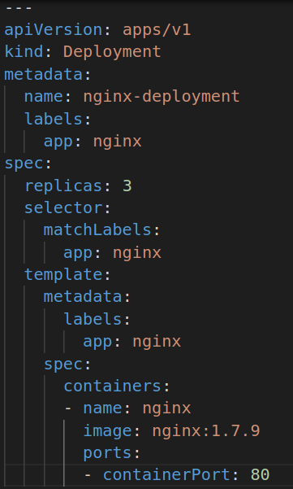

Create your service and pod, then apply them to the cluster. Once done, verify that both are running.

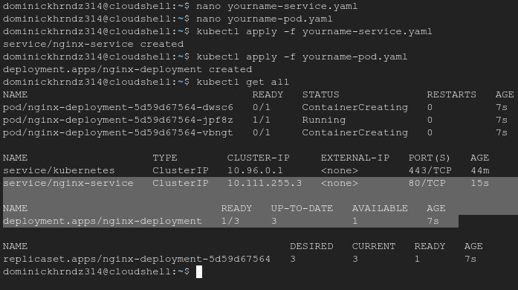

II. Identify the pod IP’s and verify connectivity between pods

Lets first identify the IP’s associated with our deployments. To this we run a new command: kubectl get po -l app=nginx -o wide. Then we can check connectivity of our pods by running the ping command.
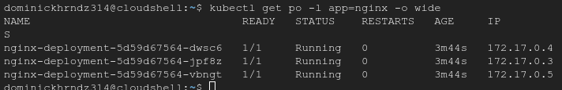

Now lets SSH into our pod and test communication between pods. We can issue the command kubectl exec -it <name of pod> – bin/bash to login to the pod of our choice. First run a ping to a destination pod.
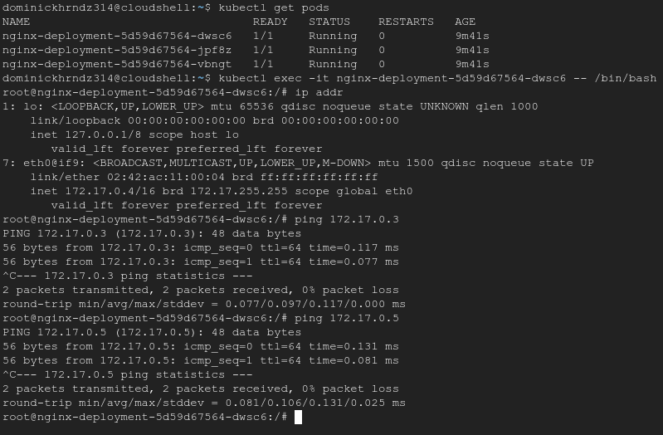
If your ping is successful you have completed this lesson for pod to pod communications.

